Predictive Modeling Analysis of Mining Accident Injury Severity

Objective
The objective of this analysis was to determine whether the degree of injury in mining accidents can be predicted using worker characteristics, occupational experience, accident conditions, and equipment-related variables. Decision tree, random forest, and xgboost models were developed and compared (Final Project).
Dataset
The Accidents.csv dataset contains 2,580 observations and 16 variables. The variables included in the analysis are: "SUBUNIT", "DEGREE_INJURY", "MINING_EQUIP", "CLASSIFICATION", "ACCIDENT_TYPE", "NO_INJURIES", "TOT_EXPER", "MINE_EXPER", "JOB_EXPER", "OCCUPATION", "ACTIVITY","INJURY_SOURCE", "NATURE_INJURY", "INJ_BODY_PART", "DAYS_RESTRICT", "DAYS_LOST"
Variable Selection
Variable related to worker subunit and occupation, mining equipment, experience, accident activity, accident type, and injury source were selected because they describe the context in which accidents occur. Variables that occur after the injury (day lost, injury body parts, days of restricted work, etc.) were excluded. This ensures the model learns from the factors that lead to the injury rather than clues after that only appear after the injury has already occurred.
To confirm the importance of these predictors, Boruta feature selection was repeated ten times. As shown in Figure 1, all nine selected variables were consistently identified as important across all runs, indicating stable and reliable predictor relevance.
Figure 1: Boruta Feature Selection Frequency
Data Preprocessing
To prepare the dataset for modeling, rows with missing values were removed so that all models were trained on complete and consistent information. After this step, the dataset was reduced from 2,580 to 2,255 observations.
Several categorical variables contained many rare categories with very few observations (Figure 2). These small groups can lead to unstable splits and overfitting in tree-based models. To reduce noise and improve model stability, categories with fewer than 20 observations were collapsed into an “OTHER” group (Figure3).

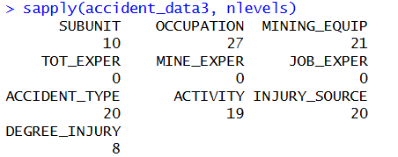
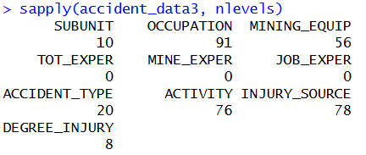
Figure 2: Original categorical levels
Figure 3: Reduced categorical levels

Validation and Metrics
To select an appropriate evaluation method, the decision tree model was tested using three approaches: independent test, cross validation, and the 0.632 bootstrap. The independent test produced a mean accuracy of 0.37 with a variance of 0.0094. Cross validation produced a mean accuracy of 0.38 with a variance of 0.012. The 0.632 bootstrap produced a mean accuracy of 0.40 with a variance of 0.022. Because the independent test yielded the lowest variance and produced results consistent with the other methods, it was selected as the evaluation method for the final models.
Confusion matrix accuracy was used as the primary evaluation metric because it provides a clear measure of overall predictive performance. Balanced accuracy was included to address class imbalance, ensuring the minority classes were weighted equally with the majority classes. Kappa was also reported because it measures how much better the model performs compared to random guessing, offering and additional check on model reliability. Together, these metrics provide a comprehensive and appropriate evaluation framework for multiclass classification problems.
Model Results
Model | Accuracy | Balanced Accuracy | Kappa
Decision Tree | 0.38 | 0.53 | 0.12
Random Forest | 0.41 | 0.56 | 0.20
Xgboost | 0.13 | 0.50 | 0.0080

Interpretation of Model Performance
The dependent variable (DEGREE_INJURY) is highly imbalanced. Some injury categories appear very often. Some appear rarely (Figure4). Because of this imbalance and multiclass structure, the relationship between predictors and injury severity is complex.
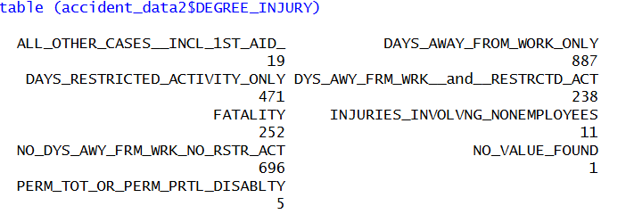
Figure 4: Degree of Injury Classes
Across all three models, the overall accuracy is lower than the balanced accuracy. This indicates that although the models struggle overall, the models are not completely failing on rare categories.
The extremely low Kappa for xgboost shows that its predictions are essentially occurring by chance, while the slightly higher kappa values for decision tree and random forest indicate that they are learning some limited structure in data.
Model Comparison
Since the dataset is largely categorical, decision trees and random forests naturally handle these predictors better than xgboost. However, a single decision tree is too simple to capture the complex interaction among workplace, equipment, and experience variables. Decision trees also are sensitive to noise and class imbalance, which further reduces their performance.
In contrast, random forest, an ensemble method, performs better because it can model complex nonlinear relationships and significantly reduce model variance. This leads to more stable and reliable predictions.
Xgboost showed the poorest predictive performance. This is likely due to categorical nature of the dataset, class imbalance, and limited training observations.
Conclusion
The results indicate that injury severity can be partially predicted using worker experience, occupational characteristics, and accident-related variables. Random Forest achieved the strongest overall performance, suggesting that ensemble methods are more effective at capturing complex relationships within the data. However, moderate accuracy and Kappa values indicate that additional data may be needed for stronger predictive performance.

Reference:
Final Project. Canvas, Iowa State University, 9 May 2026.

